1.PASSPORT MANAGEMENT SYSTEM:

CLASS DIAGRAM:

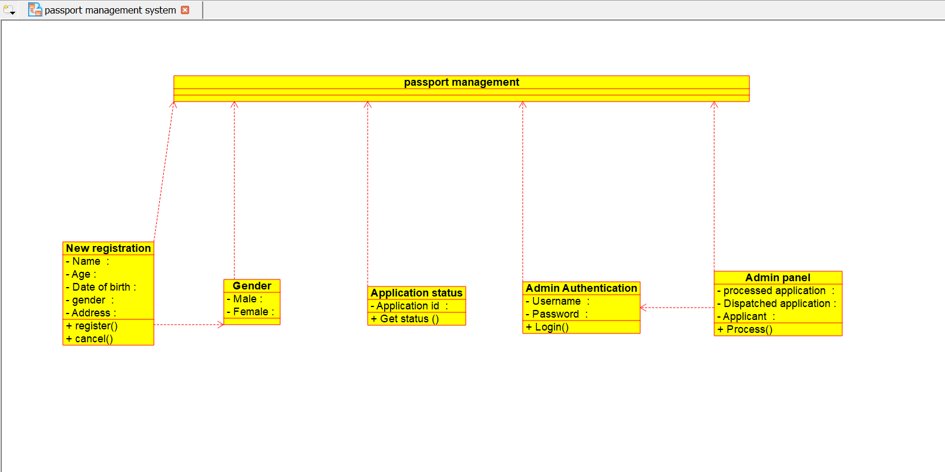SEQUENCE DIAGRAM:

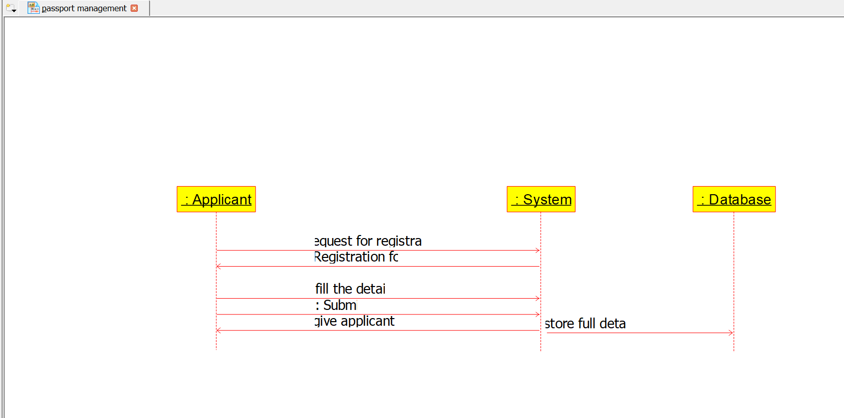

COMPONENT DIAGRAM:

2.ONLINE RESERVATION SYSTEM:

CLASS DIAGRAM:

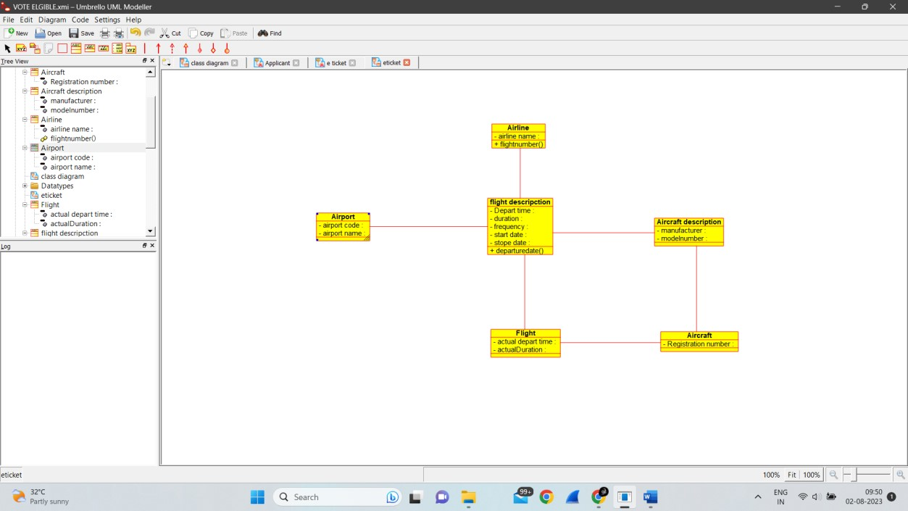

SEQUENCE DIAGRAM:

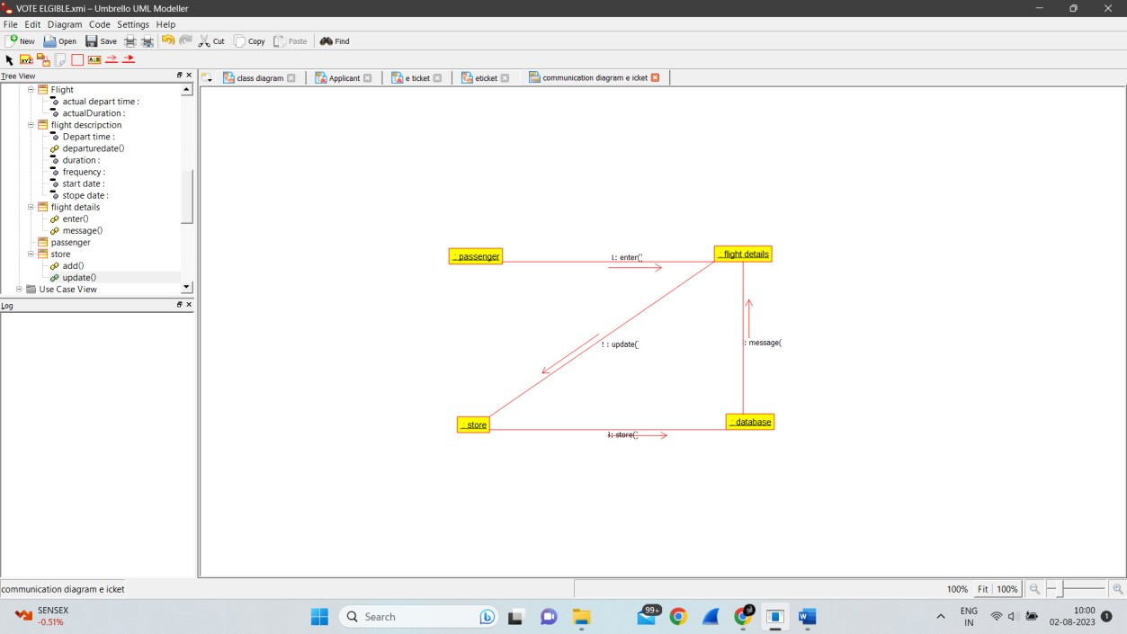

COMPONENT DIAGRAM:

3.E-TICKET SYSTEM:

CLASS DIAGRAM:



SEQUENCE DIAGRAM:



COMPONENT DIAGRAM:

4.CREDIT CARD PROCESSING SYSTEM:

CLASS DIAGRAM:

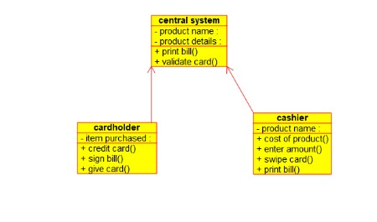

SEQUENCE DIAGRAM:

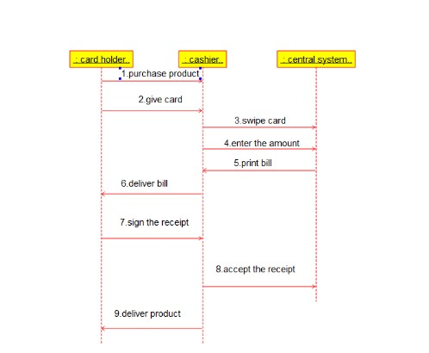

COMPONENT DIAGRAM: